NAME: S. DHARANI
REG NO: 192472364
COURSE CODE: DSA0401
NUMPY / PANDAS ANALYSIS – QUESTIONS AND ANSWERS
QUESTION 6: GROCERY PURCHASE COST CALCULATION
AIM:
To calculate the total purchase cost after applying discount and tax.
ALGORITHM:
1. Create lists for item prices and quantities.
2. Multiply each price by its quantity.
3. Calculate subtotal.
4. Subtract the discount amount.
5. Add tax to the discounted amount.
6. Display the final cost.
CODE:
prices = [100, 300, 200]
quantities = [2, 1, 1]
discount_rate = 10
tax_rate = 5
subtotal = sum(p * q for p, q in zip(prices, quantities))
discount = subtotal * discount_rate / 100
after_discount = subtotal - discount
tax = after_discount * tax_rate / 100
total = after_discount + tax
print("Subtotal:", subtotal)
print("Discount:", discount)
print("Tax:", tax)
print("Total cost:", total)
INPUT:
Prices = [100, 50, 200]
Quantities = [2, 3, 1]
Discount = 10%, Tax = 5%
OUTPUT:
Subtotal: 550
Discount: 55.0
Tax: 24.75
Total cost: 519.75
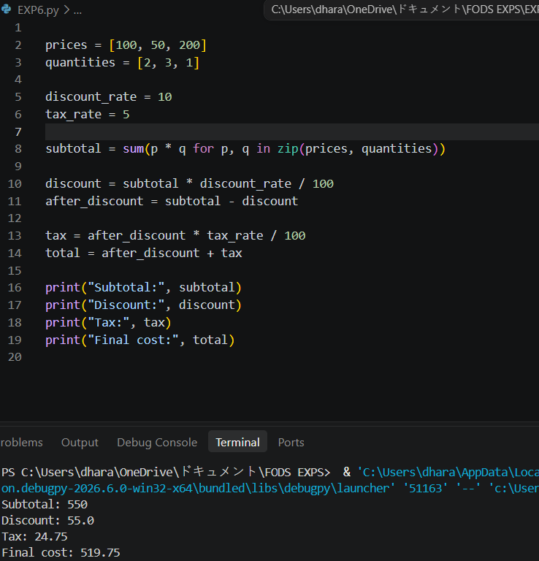
RESULT: The final purchase cost was calculated successfully.

